The Department of History is pleased to announce the following talk:

Indravati Félicité,
Maîtresse de conférences, Université Paris-Diderot (Paris VII)

"Diplomacy as a Means of Political Survival:
The Cities and Duchies of the Northern Holy Roman Empire in relation to France, 1650–1730"

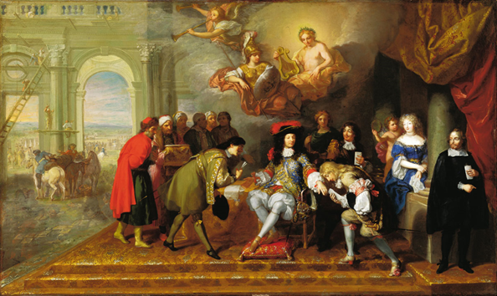

Thursday, 27 October 2016, 4 p.m. in HSSB 4020

Indravati Félicité is the author of Négocier pour exister. Les villes et duchés du nord de l’Empire face à la France 1650–1730 (Berlin : Walter de Gruyter, 2016). This talk analyzes France’s impact on the politics of the Hanseatic cities of Lübeck, Bremen, and Hamburg and the duchies of Schleswig-Holstein-Gottorp and Mecklenburg-Schwerin at the time of King Louis XIV. This was a period of change in the constitutional premises of the Holy Roman Empire. For these German "states" as well as for the diplomats and statesmen involved in these relations, negotiation and diplomacy became a matter of life and death, essential for safeguarding the existence of their governments. The place held by the diplomats in this process underlines the importance of their networks and reveals their contribution to the genesis of the early modern State.

