Transience, Garbage, Excess, Loss: The Ephemeral, 1500-1800
University of California, Santa Barbara
Conference Date: April 21-22, 2017
Abstracts Due: January 1, 2017 [EXTENDED]

The Early Modern Center at the University of California, Santa Barbara invites proposals for our annual conference, “Transience, Garbage, Excess, Loss: The Ephemeral, 1500-1800,” to be held on April 21 and 22, 2017. We are happy to announce our two keynote speakers: Elizabeth Heckendorn Cook (UC, Santa Barbara) and Jonathan Goldberg (Emory).

We invite presentations that connect broadly to our theme of ephemerality in early modernity. With the present rise of ephemera studies, we hope to investigate the limits, depths, and abilities of the ephemeral as it may pertain to literature, art, music, history, religion, philosophy, or other fields of inquiry. How is the ephemeral intimately connected to our study of early modernity? And what is at stake in plumbing what is, by definition, “short-lived” or “transitory”?

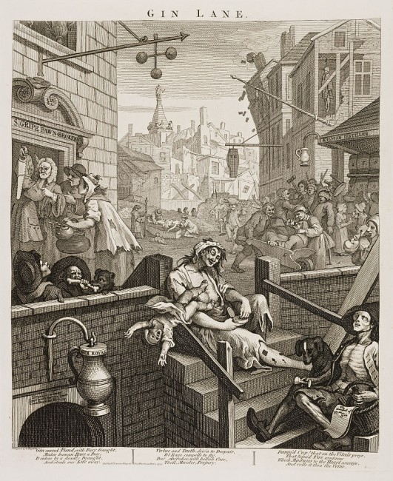
Possible topics include, but are not limited to:
- Im/permanence; im/materiality
- Sanitation, disease, sickness, plague, sewage or early modern plumbing
- Trash or the trashy
- Fragility or frailty
- Excessive femininity, sensibility, or emotional states
- Social production, overpopulation, over crowding
- Scavengers, pests, pestilence
- Food, consumption, intoxication
- Scarcity vs. plenty
- The exile, itinerant, or transient
- The pilgrim or pilgrimage
- Textuality; the ephemerality of print
- Art, artistry, or ornamentation
- The object vs the subject
- The transatlantic
- Environmental stakes
William Hogarth, “Gin Lane” (1751)

We invite abstracts of 300 words or less and a 1-page CV to be sent to EMCConference@gmail.com by January 1, 2017. In the spirit of the ephemeral, we envision both traditional conference presentations and also roundtables that engage with panelists, respondents, and audience.
Please feel free to contact the conference organizer, Jeremy Chow, at emcfellow@gmail.com with any questions you may have.

